**Amazon Kinesis**

amazon Kinesis is an Amazon Web Service (AWS)  for processing big data in real time.

Kinesis is capable of processing hundreds of terabytes per hour from high volumes of streaming data from sources such as operating logs, financial transactions and social media feeds.

According to Amazon, Kinesis fills a gap left by Hadoop and other technologies that process data in batches, but that don't enable real-time operational decisions about constantly streaming data. That capability, in turn, simplifies the process of writing apps that rely on data that must be processed in real time.

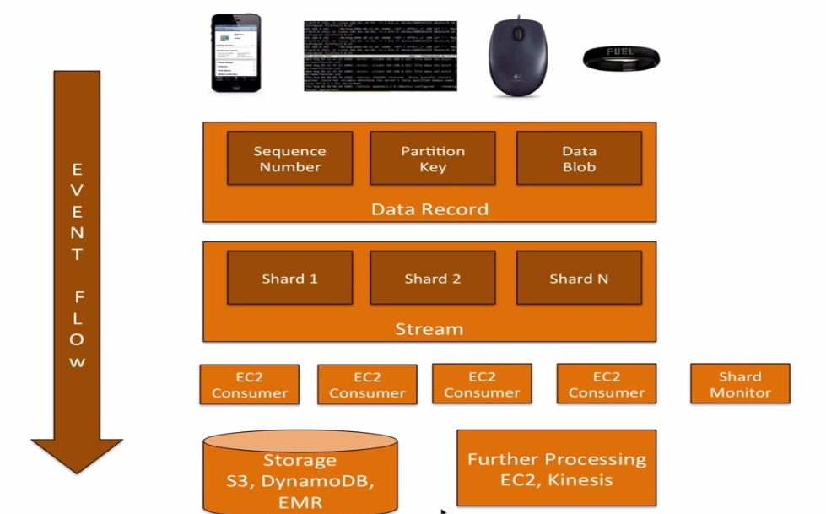

Use Amazon Kinesis Streams to collect and process large streams of data records in real time.

Kinesis is an AWS data streaming service whose job is to deliver data reliably from one end to the other while adding extensions so as to make processing data easy and scalable. It is divided into two main sub-products:

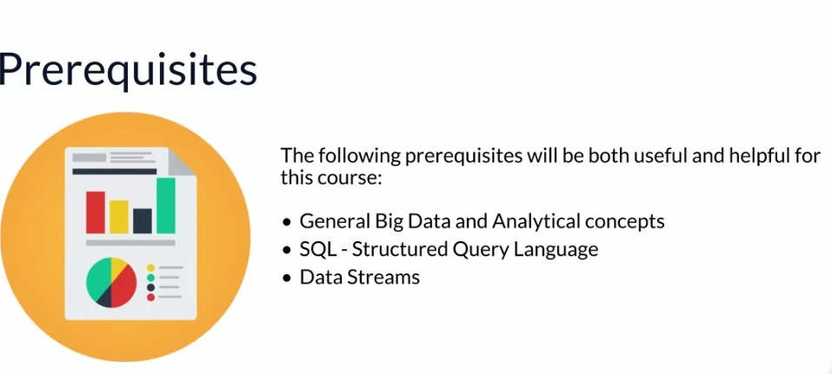

**Kinesis Streams**: Open ended data streams where you have data producers and consumers, you can define your own data consumers, this one does not scale on its own and you have to define the number of shards (capacity) you want from it beforehand.

**Kinesis Firehose**: This is same as above with the difference that it scales automatically and although data producers can be anything, data consumers are pre-defined, at the time of writing the article, valid consumers were:a. Amazon S3b. Amazon Elastic Search servicec. Amazon Redshiftd. Amazon Kinesis Analytics service